**TUGAS PEMEROGRAMAN SELVER SIDE TI 2 A**

**CODEIGNTER**



Disusun oleh

Nama : Putu Widyarsa

Nim : 1755201087

UNIVERSITAS LANCANG KUNING  
T.A 2017/2018

Bagian awal pembukaan

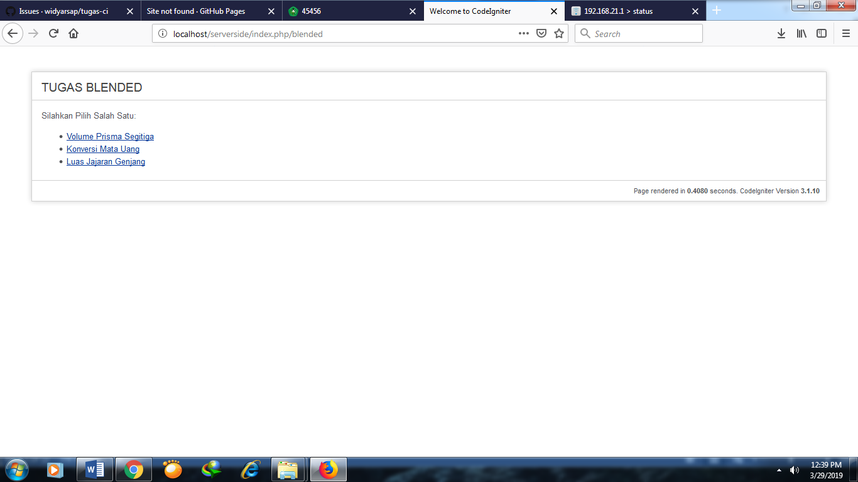

1.Volume Prima Segitiga

<?php

defined('BASEPATH') OR exit('No direct script access allowed');

?><!DOCTYPE html>

<html lang="en">

<head>

<meta charset="utf-8">

<title>Welcome to CodeIgniter</title>

<style type="text/css">

::selection { background-color: #E13300; color: white; }

::-moz-selection { background-color: #E13300; color: white; }

body {

background-color: #fff;

margin: 40px;

font: 13px/20px normal Helvetica, Arial, sans-serif;

color: #4F5155;

}

a {

color: #003399;

background-color: transparent;

font-weight: normal;

}

h1 {

color: #444;

background-color: transparent;

border-bottom: 1px solid #D0D0D0;

font-size: 19px;

font-weight: normal;

margin: 0 0 14px 0;

padding: 14px 15px 10px 15px;

}

code {

font-family: Consolas, Monaco, Courier New, Courier, monospace;

font-size: 12px;

background-color: #f9f9f9;

border: 1px solid #D0D0D0;

color: #002166;

display: block;

margin: 14px 0 14px 0;

padding: 12px 10px 12px 10px;

}

#body {

margin: 0 15px 0 15px;

}

p.footer {

text-align: right;

font-size: 11px;

border-top: 1px solid #D0D0D0;

line-height: 32px;

padding: 0 10px 0 10px;

margin: 20px 0 0 0;

}

#container {

margin: 10px;

border: 1px solid #D0D0D0;

box-shadow: 0 0 8px #D0D0D0;

}

</style>

</head>

<body>

<div id="container">

<h1>Volume Prisma Segitiga</h1>

<div id="body">

<p>Silahkan Masukkan Data:</p>

<ul>

<?php echo form_open('blended/volumeps'); ?>

<p> Panjang<br><?php echo form_input('v1',$v1); ?> cm<br></p>

<p> Lebar<br><?php echo form_input('v2',$v2); ?> cm<br></p>

<p> Tinggi<br><?php echo form_input('v3',$v3); ?> cm<br></p>

<p><?php echo validation_errors(); ?></p>

<?php echo form_submit('submit','Hitung'); ?>

<?php echo form_close(); ?> <br>

Hasil : <?php echo $hasil; ?>cm<sup>3</sup>

</ul>

<p><?php echo anchor('blended','Home'); ?></p>

</div>

<p class="footer">Page rendered in <strong>{elapsed_time}</strong> seconds. <?php echo (ENVIRONMENT === 'development') ? 'CodeIgniter Version <strong>' . CI_VERSION . '</strong>' : '' ?></p>

</div>

</body>

</html>

**Hasil yang sudah jadi**

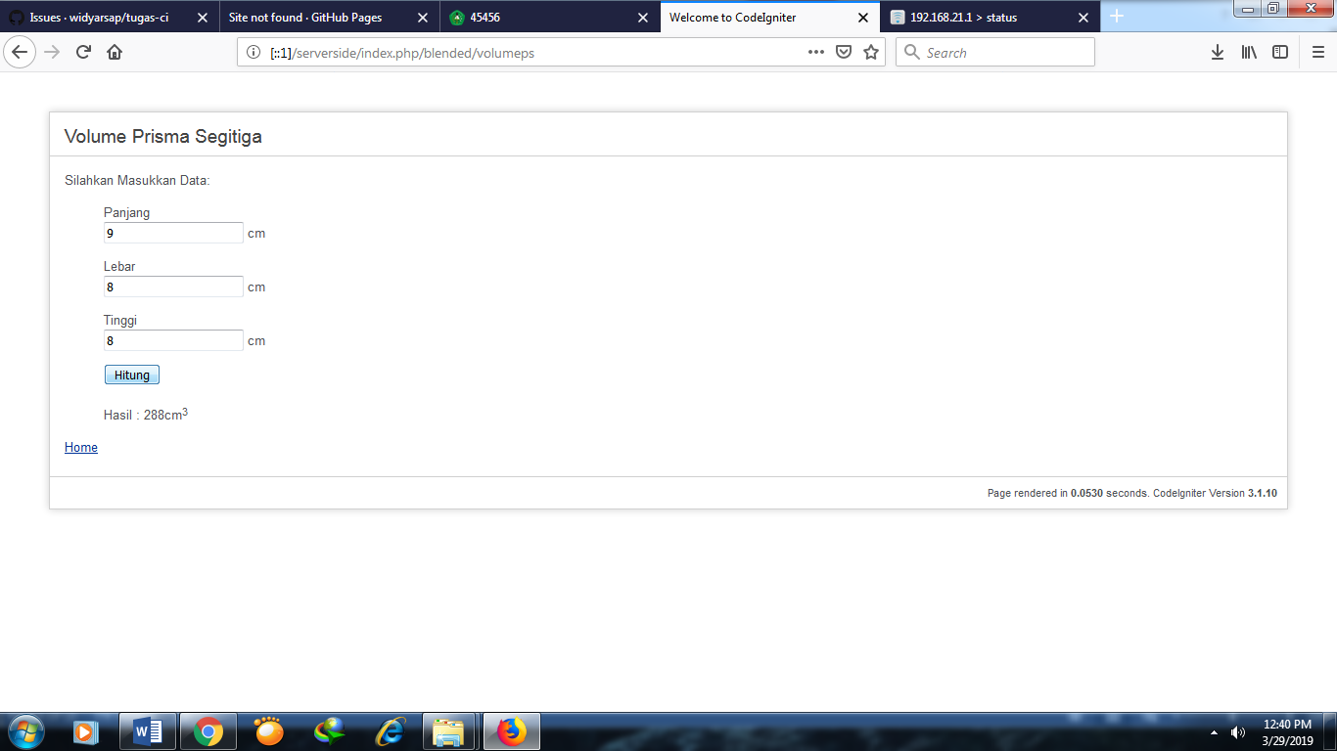

2. Konversi Mata Uang

<?php

defined('BASEPATH') OR exit('No direct script access allowed');

?><!DOCTYPE html>

<html lang="en">

<head>

<meta charset="utf-8">

<title>Welcome to CodeIgniter</title>

<style type="text/css">

::selection { background-color: #E13300; color: white; }

::-moz-selection { background-color: #E13300; color: white; }

body {

background-color: #fff;

margin: 40px;

font: 13px/20px normal Helvetica, Arial, sans-serif;

color: #4F5155;

}

a {

color: #003399;

background-color: transparent;

font-weight: normal;

}

h1 {

color: #444;

background-color: transparent;

border-bottom: 1px solid #D0D0D0;

font-size: 19px;

font-weight: normal;

margin: 0 0 14px 0;

padding: 14px 15px 10px 15px;

}

code {

font-family: Consolas, Monaco, Courier New, Courier, monospace;

font-size: 12px;

background-color: #f9f9f9;

border: 1px solid #D0D0D0;

color: #002166;

display: block;

margin: 14px 0 14px 0;

padding: 12px 10px 12px 10px;

}

#body {

margin: 0 15px 0 15px;

}

p.footer {

text-align: right;

font-size: 11px;

border-top: 1px solid #D0D0D0;

line-height: 32px;

padding: 0 10px 0 10px;

margin: 20px 0 0 0;

}

#container {

margin: 10px;

border: 1px solid #D0D0D0;

box-shadow: 0 0 8px #D0D0D0;

}

</style>

</head>

<body>

<div id="container">

<h1>Konversi Mata Uang</h1>

<div id="body">

<p>Silahkan Masukkan Data:</p>

<ul>

<?php echo form_open('blendedpuput/matauang'); ?>

<p>Indonesian Rupiah <br><?php echo form_input('v1',$v1); ?> <br></p>

<p><?php echo validation_errors(); ?></p>

<?php echo form_submit('submit','Konversi'); ?>

<?php echo form_close(); ?> <br>

<p>Singapore Dollar : <?php echo (round($v2,2,PHP_ROUND_HALF_UP)); ?> <br></p>

<p>Thai Baht : <?php echo (round($v3,2,PHP_ROUND_HALF_UP)); ?> <br></p>

<p>Philippines Peso : <?php echo (round($v4,2,PHP_ROUND_HALF_UP)); ?> <br></p>

</ul>

<p><?php echo anchor('blendedpuput','Home'); ?></p>

</div>

<p class="footer">Page rendered in <strong>{elapsed_time}</strong> seconds. <?php echo (ENVIRONMENT === 'development') ? 'CodeIgniter Version <strong>' . CI_VERSION . '</strong>' : '' ?></p>

</div>

</body>

</html>

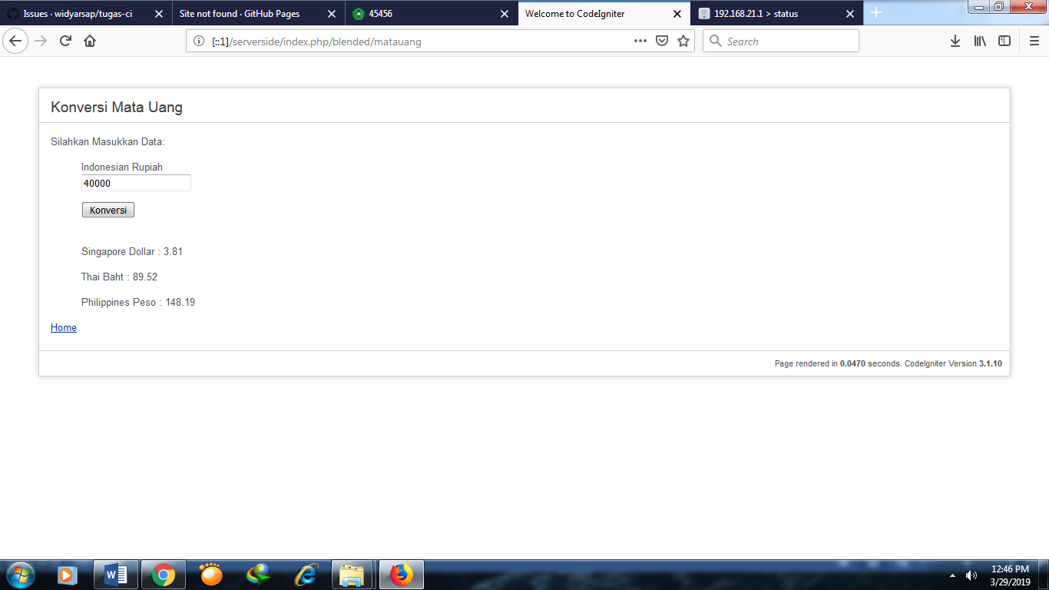

3.Luas Jajaran Genjang

<?php

defined('BASEPATH') OR exit('No direct script access allowed');

?><!DOCTYPE html>

<html lang="en">

<head>

<meta charset="utf-8">

<title>Welcome to CodeIgniter</title>

<style type="text/css">

::selection { background-color: #E13300; color: white; }

::-moz-selection { background-color: #E13300; color: white; }

body {

background-color: #fff;

margin: 40px;

font: 13px/20px normal Helvetica, Arial, sans-serif;

color: #4F5155;

}

a {

color: #003399;

background-color: transparent;

font-weight: normal;

}

h1 {

color: #444;

background-color: transparent;

border-bottom: 1px solid #D0D0D0;

font-size: 19px;

font-weight: normal;

margin: 0 0 14px 0;

padding: 14px 15px 10px 15px;

}

code {

font-family: Consolas, Monaco, Courier New, Courier, monospace;

font-size: 12px;

background-color: #f9f9f9;

border: 1px solid #D0D0D0;

color: #002166;

display: block;

margin: 14px 0 14px 0;

padding: 12px 10px 12px 10px;

}

#body {

margin: 0 15px 0 15px;

}

p.footer {

text-align: right;

font-size: 11px;

border-top: 1px solid #D0D0D0;

line-height: 32px;

padding: 0 10px 0 10px;

margin: 20px 0 0 0;

}

#container {

margin: 10px;

border: 1px solid #D0D0D0;

box-shadow: 0 0 8px #D0D0D0;

}

</style>

</head>

<body>

<div id="container">

<h1>Menghitung Luas Jajaran Genjang</h1>

<div id="body">

<p>Silahkan Masukkan Data:</p>

<ul>

<?php echo form_open('blendedpuput/luasjg'); ?>

<p>Alas <br><?php echo form_input('v1',$v1); ?> cm<br></p>

<p>Tinggi<br> <?php echo form_input('v2',$v2); ?> cm<br></p>

<p><?php echo validation_errors(); ?></p>

<?php echo form_submit('submit','Hitung'); ?>

<?php echo form_close(); ?> <br>

Hasil : <?php echo $hasil; ?>cm<sup>2</sup>

</ul>

<p><?php echo anchor('blendedpuput','Home'); ?></p>

</div>

<p class="footer">Page rendered in <strong>{elapsed_time}</strong> seconds. <?php echo (ENVIRONMENT === 'development') ? 'CodeIgniter Version <strong>' . CI_VERSION . '</strong>' : '' ?></p>

</div>

</body>

</html>

